

**UNIVERSITI MALAYSIA TERENGGANU**

**CSM3023 WEB BASED APPLICATION DEVELOPMENT**

**BACHELOR OF COMPUTER SCIENCE (MOBILE COMPUTING) WITH HONORS**

**LAB 08**

**SEMESTER I 2023/2024**

**­­**

**­­­Prepared for:**

DR MOHAMAD NOR BIN HASSAN

**Prepared by:**

NUR ATIRAH BINTI SHAMSUDDIN (S67397)

**Task 1: Employee**

**MYSQL**:

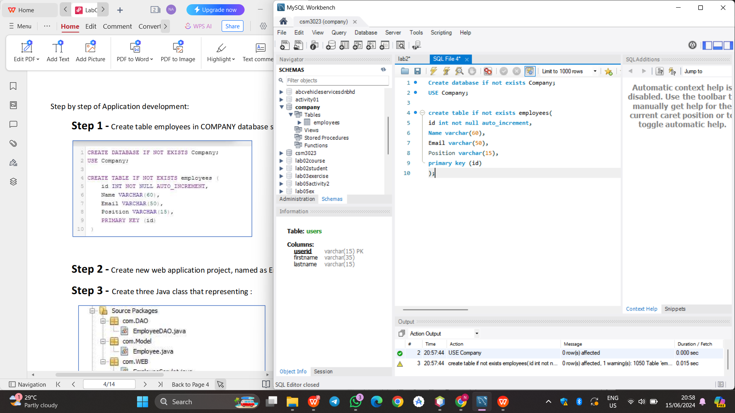

**EmployeeDAO.java**

|  |
| --- |
| /*  * Click nbfs://nbhost/SystemFileSystem/Templates/Licenses/license-default.txt to change this license  * Click nbfs://nbhost/SystemFileSystem/Templates/Classes/Class.java to edit this template  */  package com.DAO;  /**  *  * @author USER  */  import java.sql.*;  import java.sql.SQLException;  import java.util.*;  import com.Model.Employee;  public class EmployeeDAO {  Connection connection = null;  private String jdbcURL = "jdbc:mysql://localhost:3306/csm3023";  private String jdbcUsername = "root";  private String jdbcPassword = "admin";    private static final String INSERT_EMPLOYEES_SQL = "INSERT INTO employees(name, email, position) VALUES (?, ?, ?);";  private static final String SELECT_EMPLOYEE_BY_ID = "select id,name,email,position from employees where id=?";  private static final String SELECT_ALL_EMPLOYEES = "select * from employees";  private static final String DELETE_EMPLOYEES_SQL = "delete from employees where id = ?;";  private static final String UPDATE_EMPLOYEES_SQL = "update employees set name = ?,email= ?, position= ? where id = ?;";    public EmployeeDAO(){}    protected Connection getConnection(){  Connection connection = null;  try{  Class.forName("com.mysql.cj.jdbc.Driver");  connection = DriverManager.getConnection(jdbcURL, jdbcUsername, jdbcPassword);  System.out.println("Database connected!");  }catch(SQLException e){  e.printStackTrace();  }catch(ClassNotFoundException e){  e.printStackTrace();  }  return connection;  }    public void insertEmployee(Employee employee) throws SQLException{  System.out.println(INSERT_EMPLOYEES_SQL);  try(Connection connection = getConnection(); PreparedStatement preparedStatement =  connection.prepareStatement(INSERT_EMPLOYEES_SQL)){  preparedStatement.setString(1, employee.getName());  preparedStatement.setString(2, employee.getEmail());  preparedStatement.setString(3, employee.getPosition());  System.out.println(preparedStatement);  preparedStatement.executeUpdate();  }catch(SQLException e){  printSQLException(e);  }  }    public Employee selectEmployee(int id){  Employee employee = null;  // Step 1: Establishing a Connection  try(Connection connection = getConnection();  // Step 2: Create a statement using connection  PreparedStatement preparedStatement = connection.prepareStatement(SELECT_EMPLOYEE_BY_ID);){  preparedStatement.setInt(1, id);  System.out.println(preparedStatement);  ResultSet rs = preparedStatement.executeQuery();    while(rs.next()){  String name = rs.getString("name");  String email = rs.getString("email");  String position = rs.getString("position");  employee = new Employee(id, name, email,position);  }  }catch (SQLException e){  printSQLException(e);  }  return employee;  }    public List < Employee > selectAllEmployees(){  List < Employee > employees = new ArrayList < > ();  try (Connection connection = getConnection();    PreparedStatement preparedStatement = connection.prepareStatement(SELECT_ALL_EMPLOYEES);){  System.out.println(preparedStatement);  ResultSet rs = preparedStatement.executeQuery();    while(rs.next()){  int id = rs.getInt("id");  String name = rs.getString("name");  String email = rs.getString("email");  String position = rs.getString("position");  employees.add(new Employee(id, name, email, position));  }  }catch(SQLException e){  printSQLException(e);  }  return employees;  }    public boolean deleteEmployee(int id) throws SQLException{  boolean rowDeleted;  try(Connection connection = getConnection(); PreparedStatement statement =  connection.prepareStatement(DELETE_EMPLOYEES_SQL);){  statement.setInt(1, id);  rowDeleted = statement.executeUpdate() > 0;  }  return rowDeleted;  }    public boolean updateEmployee(Employee employee) throws SQLException{  boolean rowUpdated;  try(Connection connection = getConnection(); PreparedStatement statement =  connection.prepareStatement(UPDATE_EMPLOYEES_SQL);){  statement.setString(1, employee.getName());  statement.setString(2, employee.getEmail());  statement.setString(3, employee.getPosition());  statement.setInt(4, employee.getId());    rowUpdated = statement.executeUpdate() > 0;  }  return rowUpdated;  }    private void printSQLException(SQLException ex){  for(Throwable e: ex){  if(e instanceof SQLException){  e.printStackTrace(System.err);  System.err.println("SQLState: " + ((SQLException) e).getSQLState());  System.err.println("Error Code: " + ((SQLException) e).getErrorCode());  System.err.println("Message: " + e.getMessage());  Throwable t = ex.getCause();  while(t != null){  System.out.println("Cause: " + t);  t = t.getCause();  }  }  }  }    } |

**Employee.java**

|  |
| --- |
| /*  * Click nbfs://nbhost/SystemFileSystem/Templates/Licenses/license-default.txt to change this license  * Click nbfs://nbhost/SystemFileSystem/Templates/Classes/Class.java to edit this template  */  package com.Model;  /**  *  * @author USER  */  public class Employee {  protected int id;  protected String name;  protected String email;  protected String position;    public Employee() {}    public Employee(String name, String email, String position) {  super();  this.name = name;  this.email = email;  this.position = position;  }    public Employee(int id, String name, String email, String position) {  this.id = id;  this.name = name;  this.email = email;  this.position = position;  }  public int getId() {  return id;  }  public void setId(int id) {  this.id = id;  }  public String getName() {  return name;  }  public void setName(String name) {  this.name = name;  }  public String getEmail() {  return email;  }  public void setEmail(String email) {  this.email = email;  }  public String getPosition() {  return position;  }  public void setPosition(String position) {  this.position = position;  }  } |

**EmployeeServlet.java**

|  |
| --- |
| /*  * Click nbfs://nbhost/SystemFileSystem/Templates/Licenses/license-default.txt to change this license  * Click nbfs://nbhost/SystemFileSystem/Templates/JSP_Servlet/Servlet.java to edit this template  */  package com.WEB;  import com.DAO.EmployeeDAO;  import com.Model.Employee;  import jakarta.servlet.RequestDispatcher;  import java.io.IOException;  import java.io.PrintWriter;  import jakarta.servlet.ServletException;  import jakarta.servlet.annotation.WebServlet;  import jakarta.servlet.http.HttpServlet;  import jakarta.servlet.http.HttpServletRequest;  import jakarta.servlet.http.HttpServletResponse;  import java.sql.SQLException;  import java.util.List;  /**  *  * @author USER  */  @WebServlet("/")  public class EmployeeServlet extends HttpServlet {  /**  * Processes requests for both HTTP <code>GET</code> and <code>POST</code>  * methods.  *  * @param request servlet request  * @param response servlet response  * @throws ServletException if a servlet-specific error occurs  * @throws IOException if an I/O error occurs  */  private EmployeeDAO employeeDAO;    @Override  public void init(){  employeeDAO = new EmployeeDAO();  }  // <editor-fold defaultstate="collapsed" desc="HttpServlet methods. Click on the + sign on the left to edit the code.">  /**  * Handles the HTTP <code>GET</code> method.  *  * @param request servlet request  * @param response servlet response  * @throws ServletException if a servlet-specific error occurs  * @throws IOException if an I/O error occurs  */  @Override  protected void doGet(HttpServletRequest request, HttpServletResponse response)  throws ServletException, IOException {  String action = request.getServletPath();    try{  switch(action){  case "/new":  showNewForm(request, response);  break;  case "/insert":  insertEmployee(request, response);  break;  case "/delete":  deleteEmployee(request, response);  break;  case "/edit":  showEditForm(request, response);  break;  case "/update":  updateEmployee(request, response);  break;  default:  listEmployee(request, response);  break;  }  }catch(SQLException ex){  throw new ServletException(ex);  }  }    private void listEmployee(HttpServletRequest request, HttpServletResponse response)  throws SQLException, IOException, ServletException{  List < Employee > listEmployee = employeeDAO.selectAllEmployees();  request.setAttribute("listEmployee", listEmployee);  RequestDispatcher dispatcher = request.getRequestDispatcher("EmployeeList.jsp");  dispatcher.forward(request, response);  }    private void showNewForm(HttpServletRequest request, HttpServletResponse response)  throws ServletException, IOException{  RequestDispatcher dispatcher = request.getRequestDispatcher("EmployeeForm.jsp");  dispatcher.forward(request, response);  }    private void showEditForm(HttpServletRequest request, HttpServletResponse response)  throws SQLException, ServletException, IOException{  int id = Integer.parseInt(request.getParameter("id"));  Employee existingEmployee = employeeDAO.selectEmployee(id);  RequestDispatcher dispatcher = request.getRequestDispatcher("EmployeeForm.jsp");  request.setAttribute("employee", existingEmployee);  dispatcher.forward(request, response);  }    private void insertEmployee(HttpServletRequest request, HttpServletResponse response)  throws SQLException, IOException{  String name = request.getParameter("name");  String email = request.getParameter("email");  String position = request.getParameter("position");  Employee newEmployee = new Employee(name, email, position);  employeeDAO.insertEmployee(newEmployee);  response.sendRedirect("list");  }    private void updateEmployee(HttpServletRequest request, HttpServletResponse response)  throws SQLException, IOException{  int id = Integer.parseInt(request.getParameter("id"));  String name = request.getParameter("name");  String email = request.getParameter("email");  String position = request.getParameter("position");    Employee employee = new Employee(id, name, email, position);  employeeDAO.updateEmployee(employee);  response.sendRedirect("list");  }    private void deleteEmployee(HttpServletRequest request, HttpServletResponse response)  throws SQLException, IOException{  int id = Integer.parseInt(request.getParameter("id"));  employeeDAO.deleteEmployee(id);  response.sendRedirect("list");  }    /**  * Handles the HTTP <code>POST</code> method.  *  * @param request servlet request  * @param response servlet response  * @throws ServletException if a servlet-specific error occurs  * @throws IOException if an I/O error occurs  */  @Override  protected void doPost(HttpServletRequest request, HttpServletResponse response)  throws ServletException, IOException {  doGet(request, response);  }  /**  * Returns a short description of the servlet.  *  * @return a String containing servlet description  */  @Override  public String getServletInfo() {  return "Short description";  }// </editor-fold>  } |

**EmployeeForm.jsp**

|  |
| --- |
| <%--  Document : index  Created on : 5 Jun 2024, 11:20:43 pm  Author : Atirah s67397  --%>  <%@page contentType="text/html" pageEncoding="UTF-8"%>  <%@taglib uri="http://java.sun.com/jsp/jstl/core" prefix="c"%>  <!DOCTYPE html>  <html>  <head>  <meta http-equiv="Content-Type" content="text/html; charset=UTF-8">  <title>Employee Management Application</title>  <link rel="stylesheet" href="https://stackpath.bootstrapcdn.com/bootstrap/4.3.1/css/bootstrap.min.css"  integrity="sha384-ggOyR0iXCbMQv3Xipma34MD+dH/1fQ784/j6cY/iJTQUOhcWr7x9JvoRxT2MZw1T" crossorigin="anonymous">    <script>  function updatePosition() {  var selectedPosition = document.getElementById("position").value;  document.getElementById("displayPosition").value = selectedPosition;  }  </script>  </head>  <body>  <header>  <nav class="navbar navbar-expand-md navbar-dark" style="background-color: tomato">  <div>  <a href="" class="navbar-brand"> Employee Management App </a>  </div>    <ul class="navbar-nav">  <li><a href="<%=request.getContextPath()%>/list" class="nav-link">Employees</a></li>  </ul>  </nav>  </header>  <br>  <div class="container col-md-5">  <div class="card">  <div class="card-body">  <c:if test="${employee != null}">  <form action="update" method="post">  </c:if>  <c:if test="${employee == null}">  <form action="insert" method="post">  </c:if>    <h2>  <c:if test="${employee != null}">  Edit Employee  </c:if>  <c:if test="${employee == null}">  Add New Employee  </c:if>  </h2>    <c:if test="${employee != null}">  <input type="hidden" name="id" value="<c:out value='${employee.id}' />" />  </c:if>    <fieldset class="form-group">  <label>Employee Name</label><input type="text" value="<c:out value='${employee.name}' />"  class="form-control" name="name" required="required">  </fieldset>    <fieldset class="form-group">  <label>Employee Email</label><input type="text" value="<c:out value='${employee.email}' />"  class="form-control" name="email">  </fieldset>    <fieldset class="form-group">  <label>Employee Position</label>  <input type="text" id="displayPosition" value="<c:out value='${employee.position}' />" class="form-control" readonly>  <input list="positionList" id="position" class="form-control" name="position" onchange="updatePosition()" >  <datalist id="positionList">  <option value="Manager">  <option value="Head of Dept">  <option value="Supervisor">  <option value="Director">  </datalist>  </fieldset>    <button type="submit" class="btn btn-success">Save</button>  </form>  </div>  </div>  </div>  </body>  </html> |

**EmployeeList.jsp**

|  |
| --- |
| <%--  Document : EmployeeList  Created on : 6 Jun 2024, 12:31:25 am  Author : Atirah S67397  --%>  <%@page contentType="text/html" pageEncoding="UTF-8"%>  <%@taglib uri="http://java.sun.com/jsp/jstl/core" prefix="c" %>  <!DOCTYPE html>  <html>  <head>  <meta http-equiv="Content-Type" content="text/html; charset=UTF-8">  <title>Employee Management System</title>  <link rel="stylesheet" href="https://stackpath.bootstrapcdn.com/bootstrap/4.3.1/css/bootstrap.min.css"  integrity="sha384-ggOyR0iXCbMQv3Xipma34MD+dH/1fQ784/j6cY/iJTQUOhcWr7x9JvoRxT2MZw1T" crossorigin="anonymous">  </head>  <body>    <header>  <nav class="navbar navbar-expand-md navbar-dark" style="background-color: tomato">  <div>  <a href="" class="navbar-brand"> Employee Management App </a>  </div>    <ul class="navbar-nav">  <li><a href="<%=request.getContextPath()%>/list" class="nav-link">Employees</a></li>  </ul>  </nav>  </header>  <br>    <div class="row">  <div class="container">  <h3 class="container">List of Employees</h3>  <hr>  <div class="container text-left">  <a href="<%=request.getContextPath()%>/new" class="btn btn-success">Add New Employee</a>  </div>  <br>  <table class="table table-bordered">  <thead>  <tr>  <th>ID</th>  <th>Name</th>  <th>Email</th>  <th>Position</th>  <th>Actions</th>  </tr>  </thead>  <tbody>  <c:forEach var="employee" items="${listEmployee}">  <tr>  <td>  <c:out value="${employee.id}" />  </td>  <td>  <c:out value="${employee.name}" />  </td>  <td>  <c:out value="${employee.email}" />  </td>  <td>  <c:out value="${employee.position}" />  </td>  <td><a href="edit?id=<c:out value='${employee.id}' />">Edit</a> &nbsp;&nbsp;&nbsp;&nbsp;  <a href="delete?id=<c:out value='${employee.id}' />">Delete</a>  </td>  </tr>  </c:forEach>  </tbody>  </table>  </div>  </div>  </body>  </html> |

**error.jsp**

|  |
| --- |
| <%--  Document : error  Created on : 6 Jun 2024, 12:47:29 am  Author : Atirah s67397  --%>  <%@page contentType="text/html" pageEncoding="UTF-8" isErrorPage="true" %>  <!DOCTYPE html>  <html>  <head>  <meta http-equiv="Content-Type" content="text/html; charset=UTF-8">  <title>Error page</title>  </head>  <body>  <center>  <h1>Error</h1>  <h2><%=exception.getMessage() %><br/></h2>  </center>  </body>  </html> |

**index.jsp**

|  |
| --- |
| <%--  Document : index  Created on : 6 Jun 2024, 12:52:38 am  Author : Atirah s67397  --%>  <%@page contentType="text/html" pageEncoding="UTF-8"%>  <!DOCTYPE html>  <html>  <head>  <meta http-equiv="Content-Type" content="text/html; charset=UTF-8">  <title>User Management Application</title>  <link rel="stylesheet" href="https://stackpath.bootstrapcdn.com/bootstrap/4.3.1/css/bootstrap.min.css"  integrity="sha384-ggOyR0iXCbMQv3Xipma34MD+dH/1fQ784/j6cY/iJTQUOhcWr7x9JvoRxT2MZw1T" crossorigin="anonymous">  </head>  <body>  <h1>Application MVC system for Employee Management</h1><br>    <ul>  <li><a href="http://localhost:8080/Employee_Management/list">All Employee List</a></li>  <li><a href="http://localhost:8080/Employee_Management/new">Add a New Employee</a></li>  <li><a href="http://localhost:8080/Employee_Management/list">Edit Employee</a></li>  </ul>  </body>  </html> |

**OUTPUT:**

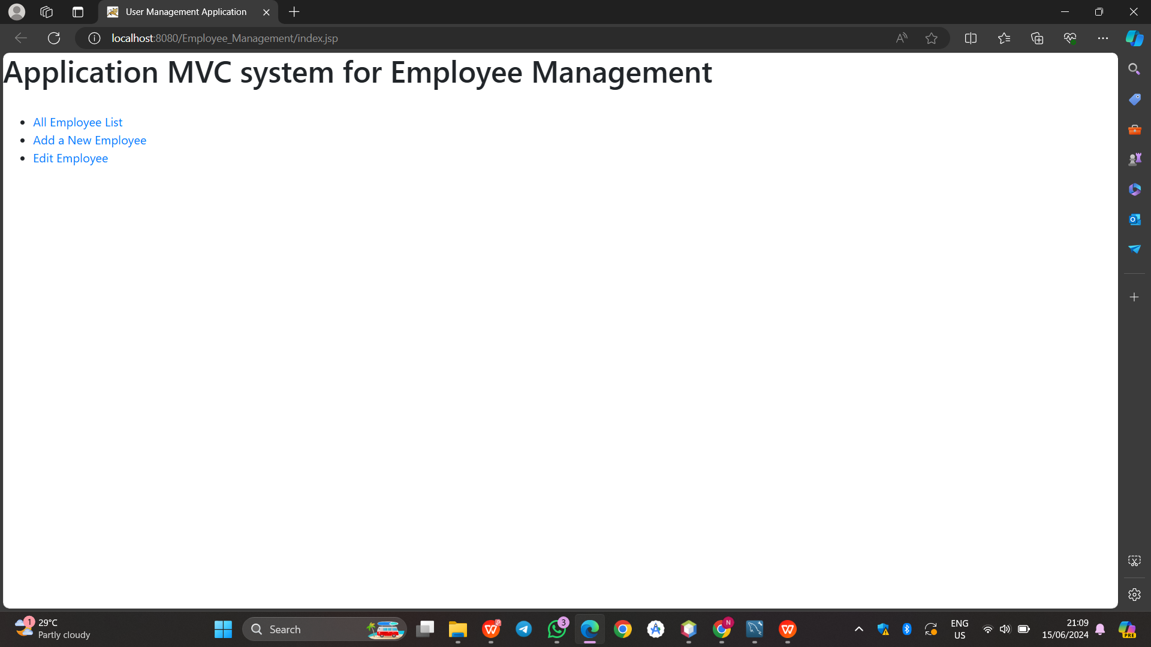

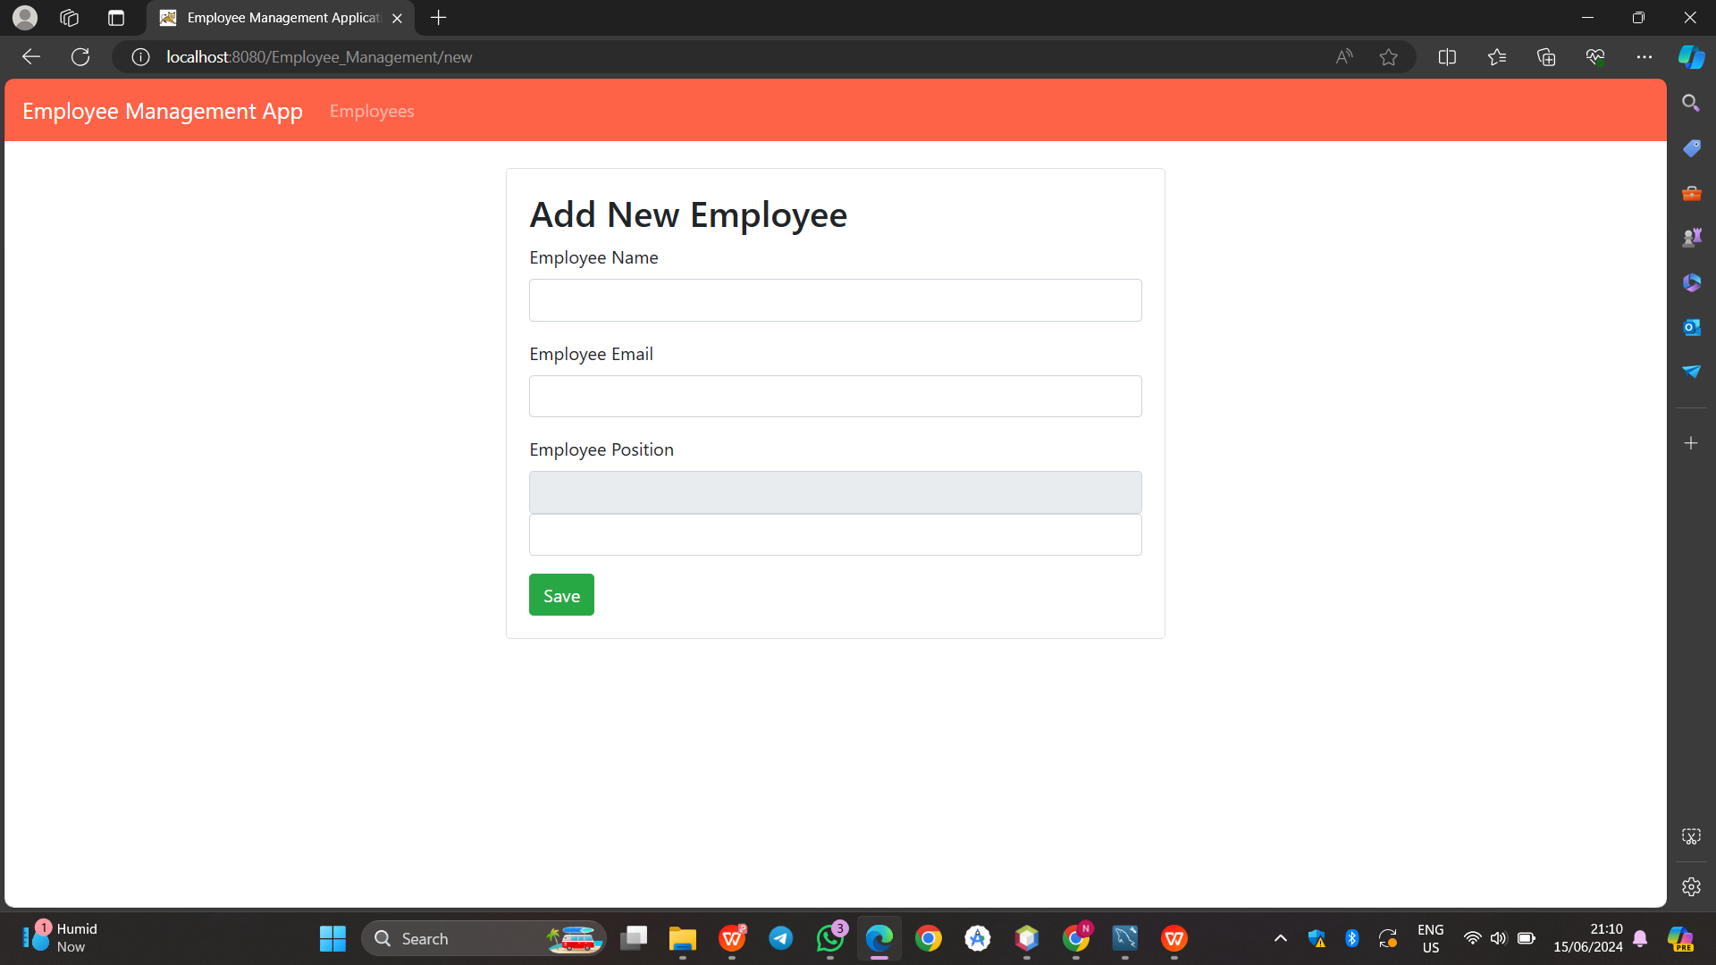

**Exercise**

Using this database shema, please create MVC Application [CRUD] for Car Shop, using JSP, Servlet, and MySQL.

CREATE DATABASE if not EXISTS carshop;

USE carshop;

CREATE TABLE if not EXISTS CarPricelist(

Car_id INT NOT NULL AUTO_INCREMENT,

Brand VARCHAR(15),

Model VARCHAR(30),

Cyclinder INT,

Price DOUBLE,

PRIMARY KEY (Car_id)

);

The application should be able to handle these activities:

1. View all data

2. Add new data

3. Edit/Update current data

4. Delete the specific data

**MYSQL:**

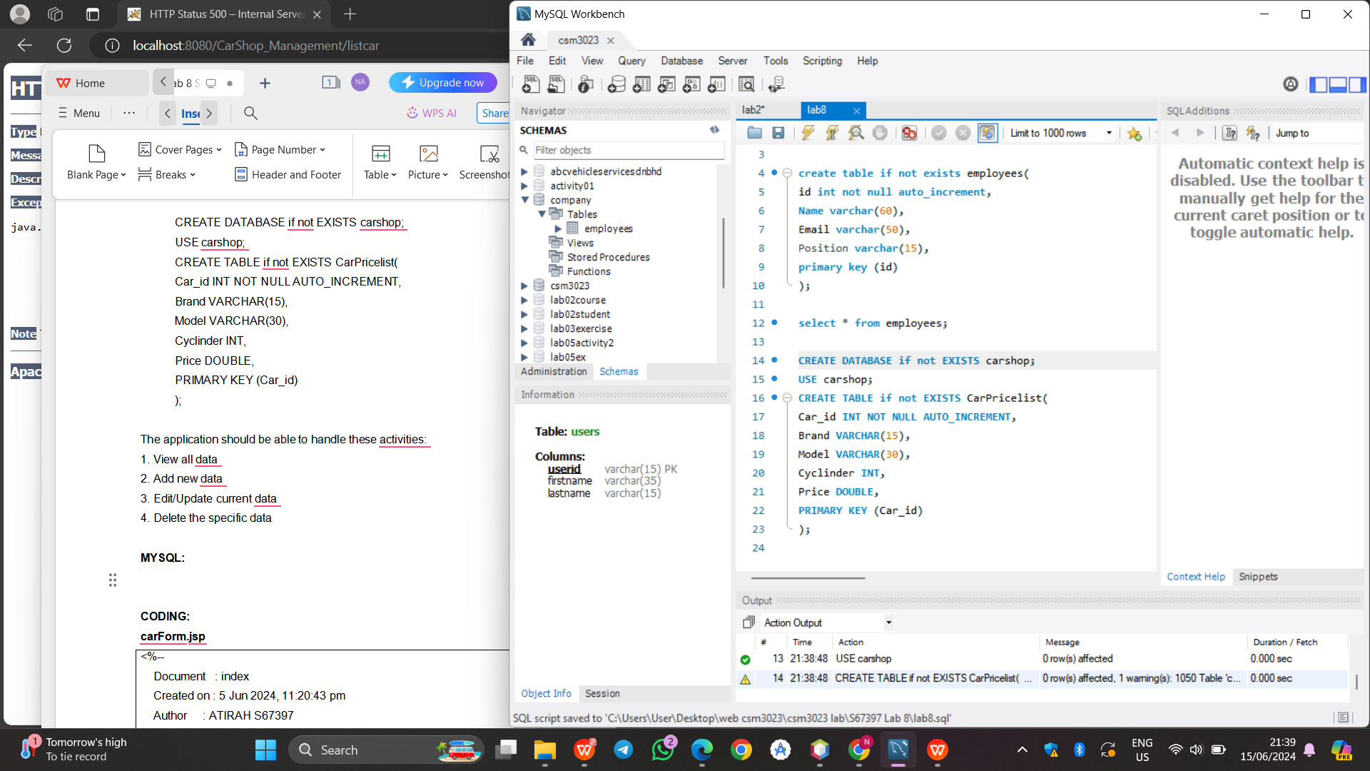

**CODING:**

**carForm.jsp**

|  |
| --- |
| <%--  Document : index  Created on : 5 Jun 2024, 11:20:43 pm  Author : ATIRAH S67397  --%>  <%@page contentType="text/html" pageEncoding="UTF-8"%>  <%@taglib uri="http://java.sun.com/jsp/jstl/core" prefix="c"%>  <!DOCTYPE html>  <html>  <head>  <meta http-equiv="Content-Type" content="text/html; charset=UTF-8">  <title>Car Shop Management Application</title>  <link rel="stylesheet" href="https://stackpath.bootstrapcdn.com/bootstrap/4.3.1/css/bootstrap.min.css"  integrity="sha384-ggOyR0iXCbMQv3Xipma34MD+dH/1fQ784/j6cY/iJTQUOhcWr7x9JvoRxT2MZw1T" crossorigin="anonymous">    <script>  function updateBrand() {  var selectedBrand = document.getElementById("brand").value;  document.getElementById("displayBrand").value = selectedBrand;  }  </script>  </head>  <body>  <header>  <nav class="navbar navbar-expand-md navbar-dark" style="background-color: tomato">  <div>  <a href="" class="navbar-brand"> Car Management Application </a>  </div>    <ul class="navbar-nav">  <li><a href="<%=request.getContextPath()%>/listcar" class="nav-link">Cars</a></li>  </ul>  </nav>  </header>  <br>  <div class="container col-md-5">  <div class="card">  <div class="card-body">  <c:if test="${car != null}">  <form action="update" method="post">  </c:if>  <c:if test="${car == null}">  <form action="insert" method="post">  </c:if>    <h2>  <c:if test="${car != null}">  Edit Car  </c:if>  <c:if test="${car == null}">  Add New Car  </c:if>  </h2>    <c:if test="${car != null}">  <input type="hidden" name="car_id" value="<c:out value='${car.id}' />" />  </c:if>    <fieldset class="form-group">  <label>Car Brand</label>  <input type="text" id="displayBrand" value="<c:out value='${car.brand}' />" class="form-control" readonly>  <input list="carList" id="brand" class="form-control" name="brand" onchange="updateBrand()" >  <datalist id="carList">  <option value="Proton">  <option value="Perodua">  <option value="Toyota">  <option value="Honda">  <option value="Nissan">  <option value="Ford">  <option value="Hyundai">  <option value="Kia">  </datalist>  </fieldset>    <fieldset class="form-group">  <label>Car Model</label><input type="text" value="<c:out value='${car.model}' />"  class="form-control" name="model" required="required">  </fieldset>    <fieldset class="form-group">  <label>Engine Cylinder</label><input type="text" value="<c:out value='${car.cylinder}' />"  class="form-control" name="cylinder">  </fieldset>    <fieldset class="form-group">  <label>Car Price</label><input type="text" value="<c:out value='${car.price}' />"  class="form-control" name="price">  </fieldset>    <button type="submit" class="btn btn-success">Save</button>  </form>  </div>  </div>  </div>  </body>  </html> |

**CarList.jsp**

|  |
| --- |
| <%--  Document : EmployeeList  Created on : 6 Jun 2024, 12:31:25 am  Author : ATIRAH S67397  --%>  <%@page contentType="text/html" pageEncoding="UTF-8"%>  <%@taglib uri="http://java.sun.com/jsp/jstl/core" prefix="c" %>  <!DOCTYPE html>  <html>  <head>  <meta http-equiv="Content-Type" content="text/html; charset=UTF-8">  <title>Car Shop Management Application</title>  <link rel="stylesheet" href="https://stackpath.bootstrapcdn.com/bootstrap/4.3.1/css/bootstrap.min.css"  integrity="sha384-ggOyR0iXCbMQv3Xipma34MD+dH/1fQ784/j6cY/iJTQUOhcWr7x9JvoRxT2MZw1T" crossorigin="anonymous">  </head>  <body>    <header>  <nav class="navbar navbar-expand-md navbar-dark" style="background-color: tomato">  <div>  <a href="" class="navbar-brand"> Car Shop Management App </a>  </div>    <ul class="navbar-nav">  <li><a href="<%=request.getContextPath()%>/listcar" class="nav-link">Cars</a></li>  </ul>  </nav>  </header>  <br>    <div class="row">  <div class="container">  <h3 class="container">List of Cars</h3>  <hr>  <div class="container text-left">  <a href="<%=request.getContextPath()%>/new" class="btn btn-success">Add New Car</a>  </div>  <br>  <table class="table table-bordered">  <thead>  <tr>  <th>ID</th>  <th>Brand</th>  <th>Model</th>  <th>Engine Cylinder</th>  <th>Price</th>  <th>Actions</th>  </tr>  </thead>  <tbody>  <c:forEach var="car" items="${listCar}">  <tr>  <td>  <c:out value="${car.car_id}" />  </td>  <td>  <c:out value="${car.brand}" />  </td>  <td>  <c:out value="${car.model}" />  </td>  <td>  <c:out value="${car.cylinder}" />  </td>  <td>  <c:out value="${car.price}" />  </td>  <td><a href="edit?car_id=<c:out value='${car.car_id}' />">Edit</a> &nbsp;&nbsp;&nbsp;&nbsp;  <a href="delete?car_id=<c:out value='${car.car_id}' />">Delete</a>  </td>  </tr>  </c:forEach>  </tbody>  </table>  </div>  </div>  </body>  </html> |

**Error.jsp**

|  |
| --- |
| <%--  Document : error  Created on : 6 Jun 2024, 12:47:29 am  Author : ATIRAH S67397  --%>  <%@page contentType="text/html" pageEncoding="UTF-8" isErrorPage="true" %>  <!DOCTYPE html>  <html>  <head>  <meta http-equiv="Content-Type" content="text/html; charset=UTF-8">  <title>Error page</title>  </head>  <body>  <center>  <h1>Error</h1>  <h2><%=exception.getMessage() %><br/></h2>  </center>  </body>  </html> |

**Index.jsp**

|  |
| --- |
| <%--  Document : index  Created on : 6 Jun 2024, 12:52:38 am  Author : ATIRAH S67397  --%>  <%@page contentType="text/html" pageEncoding="UTF-8"%>  <!DOCTYPE html>  <html>  <head>  <meta http-equiv="Content-Type" content="text/html; charset=UTF-8">  <title>Car Shop Management Application</title>  <link rel="stylesheet" href="https://stackpath.bootstrapcdn.com/bootstrap/4.3.1/css/bootstrap.min.css"  integrity="sha384-ggOyR0iXCbMQv3Xipma34MD+dH/1fQ784/j6cY/iJTQUOhcWr7x9JvoRxT2MZw1T" crossorigin="anonymous">  </head>  <body>  <h1>Car Shop Management System - Encik Ayah Used Car</h1><br>    <ul>  <li><a href="http://localhost:8080/CarShop_Management/listcar">All Car List</a></li>  <li><a href="http://localhost:8080/CarShop_Management/new">Add a New Car</a></li>  <li><a href="http://localhost:8080/CarShop_Management/listcar">Edit Car</a></li>  </ul>  </body>  </html> |

**CarDAO.java**

|  |
| --- |
| /*  * Click nbfs://nbhost/SystemFileSystem/Templates/Licenses/license-default.txt to change this license  * Click nbfs://nbhost/SystemFileSystem/Templates/Classes/Class.java to edit this template  */  package com.DAO;  /**  *  * @author ATIRAH S67397  */  import java.sql.*;  import java.sql.SQLException;  import java.util.*;  import com.model.Car;  public class CarDAO {  Connection connection = null;  private String jdbcURL = "jdbc:mysql://localhost:3306/carshop";  private String jdbcUsername = "root";  private String jdbcPassword = "admin";    private static final String INSERT_CARS_SQL = "INSERT INTO carpricelist(brand, model, cylinder, price) VALUES (?, ?, ?, ?);";  private static final String SELECT_CAR_BY_ID = "select car_id, brand, model, cylinder, price from carpricelist where car_id=?";  private static final String SELECT_ALL_CARS = "select * from carpricelist";  private static final String DELETE_CARS_SQL = "delete from carpricelist where car_id = ?;";  private static final String UPDATE_CARS_SQL = "update carpricelist set brand = ?,model= ?, cylinder= ?, price= ? where car_id = ?;";    public CarDAO(){}    protected Connection getConnection(){  Connection connection = null;  try{  Class.forName("com.mysql.cj.jdbc.Driver");  connection = DriverManager.getConnection(jdbcURL, jdbcUsername, jdbcPassword);  System.out.println("Database connected!");  }catch(SQLException e){  e.printStackTrace();  }catch(ClassNotFoundException e){  e.printStackTrace();  }  return connection;  }    public void insertCar(Car car) throws SQLException{  System.out.println(INSERT_CARS_SQL);  try(Connection connection = getConnection(); PreparedStatement preparedStatement =  connection.prepareStatement(INSERT_CARS_SQL)){  preparedStatement.setString(1, car.getBrand());  preparedStatement.setString(2, car.getModel());  preparedStatement.setInt(3, car.getCylinder());  preparedStatement.setDouble(4, car.getPrice());  System.out.println(preparedStatement);  preparedStatement.executeUpdate();  }catch(SQLException e){  printSQLException(e);  }  }    public Car selectCar(int id){  Car car = null;  // Step 1: Establishing a Connection  try(Connection connection = getConnection();  // Step 2: Create a statement using connection  PreparedStatement preparedStatement = connection.prepareStatement(SELECT_CAR_BY_ID);){  preparedStatement.setInt(1, id);  System.out.println(preparedStatement);  ResultSet rs = preparedStatement.executeQuery();    while(rs.next()){  String brand = rs.getString("brand");  String model = rs.getString("model");  int cylinder = rs.getInt("cylinder");  double price = rs.getDouble("price");  car = new Car(id, brand, model, cylinder, price);  }  }catch (SQLException e){  printSQLException(e);  }  return car;  }    public List < Car > selectAllCars(){  List <Car> cars = new ArrayList <>();  try (Connection connection = getConnection();    PreparedStatement preparedStatement = connection.prepareStatement(SELECT_ALL_CARS);){  System.out.println(preparedStatement);  ResultSet rs = preparedStatement.executeQuery();    while(rs.next()){  int id = rs.getInt("car_id");  String brand = rs.getString("brand");  String model = rs.getString("model");  int cylinder = rs.getInt("cylinder");  double price = rs.getDouble("price");  cars.add(new Car(id, brand, model, cylinder, price));  }  }catch(SQLException e){  printSQLException(e);  }  return cars;  }    public boolean deleteCar(int id) throws SQLException{  boolean rowDeleted;  try(Connection connection = getConnection(); PreparedStatement statement =  connection.prepareStatement(DELETE_CARS_SQL);){  statement.setInt(1, id);  rowDeleted = statement.executeUpdate() > 0;  }  return rowDeleted;  }    public boolean updateCar(Car car) throws SQLException{  boolean rowUpdated;  try(Connection connection = getConnection(); PreparedStatement statement =  connection.prepareStatement(UPDATE_CARS_SQL);){  statement.setString(1, car.getBrand());  statement.setString(2, car.getModel());  statement.setInt(3, car.getCylinder());  statement.setDouble(4, car.getPrice());  statement.setInt(5, car.getCar_id());    rowUpdated = statement.executeUpdate() > 0;  }  return rowUpdated;  }    private void printSQLException(SQLException ex){  for(Throwable e: ex){  if(e instanceof SQLException){  e.printStackTrace(System.err);  System.err.println("SQLState: " + ((SQLException) e).getSQLState());  System.err.println("Error Code: " + ((SQLException) e).getErrorCode());  System.err.println("Message: " + e.getMessage());  Throwable t = ex.getCause();  while(t != null){  System.out.println("Cause: " + t);  t = t.getCause();  }  }  }  }    } |

**CarServlet.java**

|  |
| --- |
| /*  * Click nbfs://nbhost/SystemFileSystem/Templates/Licenses/license-default.txt to change this license  * Click nbfs://nbhost/SystemFileSystem/Templates/JSP_Servlet/Servlet.java to edit this template  */  package com.controller;  import com.DAO.CarDAO;  import com.model.Car;  import jakarta.servlet.RequestDispatcher;  import java.io.IOException;  import java.io.PrintWriter;  import jakarta.servlet.ServletException;  import jakarta.servlet.annotation.WebServlet;  import jakarta.servlet.http.HttpServlet;  import jakarta.servlet.http.HttpServletRequest;  import jakarta.servlet.http.HttpServletResponse;  import java.sql.SQLException;  import java.util.List;  /**  *  * @author ATIRAH S67397  */  @WebServlet("/")  public class CarServlet extends HttpServlet {  /**  * Processes requests for both HTTP <code>GET</code> and <code>POST</code>  * methods.  *  * @param request servlet request  * @param response servlet response  * @throws ServletException if a servlet-specific error occurs  * @throws IOException if an I/O error occurs  */  private CarDAO carDAO;    @Override  public void init(){  carDAO = new CarDAO();  }  // <editor-fold defaultstate="collapsed" desc="HttpServlet methods. Click on the + sign on the left to edit the code.">  /**  * Handles the HTTP <code>GET</code> method.  *  * @param request servlet request  * @param response servlet response  * @throws ServletException if a servlet-specific error occurs  * @throws IOException if an I/O error occurs  */  @Override  protected void doGet(HttpServletRequest request, HttpServletResponse response)  throws ServletException, IOException {  String action = request.getServletPath();    try{  switch(action){  case "/new":  showNewForm(request, response);  break;  case "/insert":  insertCar(request, response);  break;  case "/delete":  deleteCar(request, response);  break;  case "/edit":  showEditForm(request, response);  break;  case "/update":  updateCar(request, response);  break;  default:  listCar(request, response);  break;  }  }catch(SQLException ex){  throw new ServletException(ex);  }  }    private void listCar(HttpServletRequest request, HttpServletResponse response)  throws SQLException, IOException, ServletException{  List < Car > listCar = carDAO.selectAllCars();  request.setAttribute("listCar", listCar);  RequestDispatcher dispatcher = request.getRequestDispatcher("CarList.jsp");  dispatcher.forward(request, response);  }    private void showNewForm(HttpServletRequest request, HttpServletResponse response)  throws ServletException, IOException{  RequestDispatcher dispatcher = request.getRequestDispatcher("CarForm.jsp");  dispatcher.forward(request, response);  }    private void showEditForm(HttpServletRequest request, HttpServletResponse response)  throws SQLException, ServletException, IOException{  int id = Integer.parseInt(request.getParameter("car_id"));  Car existingCar = carDAO.selectCar(id);  RequestDispatcher dispatcher = request.getRequestDispatcher("CarForm.jsp");  request.setAttribute("car", existingCar);  dispatcher.forward(request, response);  }    private void insertCar(HttpServletRequest request, HttpServletResponse response)  throws SQLException, IOException{  String brand = request.getParameter("brand");  String model = request.getParameter("model");  int cylinder = Integer.parseInt(request.getParameter("cylinder"));  double price = Double.parseDouble(request.getParameter("price"));  Car car = new Car(brand, model, cylinder, price);  carDAO.insertCar(car);  response.sendRedirect("listcar");  }    private void updateCar(HttpServletRequest request, HttpServletResponse response)  throws SQLException, IOException{  int id = Integer.parseInt(request.getParameter("car_id"));  String brand = request.getParameter("brand");  String model = request.getParameter("model");  int cylinder = Integer.parseInt(request.getParameter("cylinder"));  double price = Double.parseDouble(request.getParameter("price"));  Car car = new Car(brand, model, cylinder, price);  carDAO.updateCar(car);  response.sendRedirect("listcar");  }    private void deleteCar(HttpServletRequest request, HttpServletResponse response)  throws SQLException, IOException{  int id = Integer.parseInt(request.getParameter("car_id"));  carDAO.deleteCar(id);  response.sendRedirect("listcar");  }    /**  * Handles the HTTP <code>POST</code> method.  *  * @param request servlet request  * @param response servlet response  * @throws ServletException if a servlet-specific error occurs  * @throws IOException if an I/O error occurs  */  @Override  protected void doPost(HttpServletRequest request, HttpServletResponse response)  throws ServletException, IOException {  doGet(request, response);  }  /**  * Returns a short description of the servlet.  *  * @return a String containing servlet description  */  @Override  public String getServletInfo() {  return "Short description";  }// </editor-fold>  } |

**Car.java**

|  |
| --- |
| /*  * Click nbfs://nbhost/SystemFileSystem/Templates/Licenses/license-default.txt to change this license  * Click nbfs://nbhost/SystemFileSystem/Templates/Classes/Class.java to edit this template  */  package com.model;  /**  *  * @author ATIRAH S67397  */  public class Car {  protected int car_id;  protected String brand;  protected String model;  protected int cylinder;  protected double price;    public Car(){}  public Car(String brand, String model, int cylinder, double price) {  super();  this.brand = brand;  this.model = model;  this.cylinder = cylinder;  this.price = price;  }  public Car(int car_id, String brand, String model, int cylinder, double price) {  this.car_id = car_id;  this.brand = brand;  this.model = model;  this.cylinder = cylinder;  this.price = price;  }    public int getCar_id() {  return car_id;  }  public void setCar_id(int car_id) {  this.car_id = car_id;  }  public String getBrand() {  return brand;  }  public void setBrand(String brand) {  this.brand = brand;  }  public String getModel() {  return model;  }  public void setModel(String model) {  this.model = model;  }  public int getCylinder() {  return cylinder;  }  public void setCylinder(int cylinder) {  this.cylinder = cylinder;  }  public double getPrice() {  return price;  }  public void setPrice(double price) {  this.price = price;  }    } |

**OUTPUT:**

